Tunic

Fernando de la Cerda's Pellote
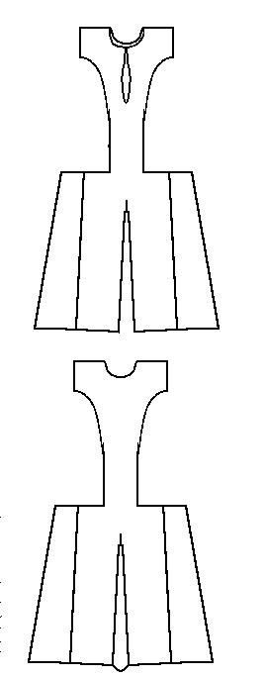
based on photographs
This garment is referred to in Museo de Telas Medievales as Pellote de Leonora de Castilla, Reina de Aragón (c.1225-1275).

