Tunic

Fernando's Pellote
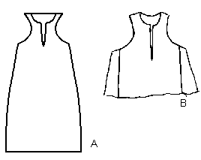
Drawing based on photographs in Museo de Telas Medievales.
Museo de Telas Medievales Pellote de Fernando, Hijo de Alfonso X. And a fragment.

