Tunic

Birgitta's Cloak or Dress
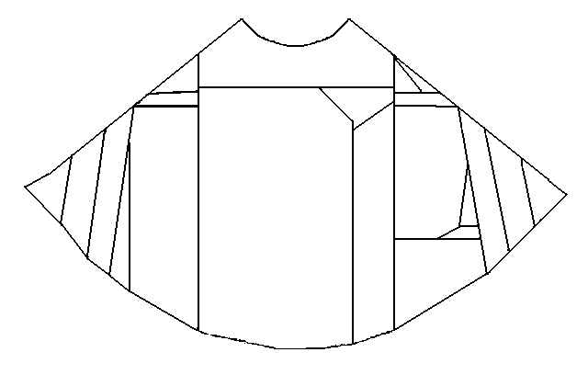
traditional layout of the "Mantle of St. Birgitta". After photographs in Andersson and Franzén.
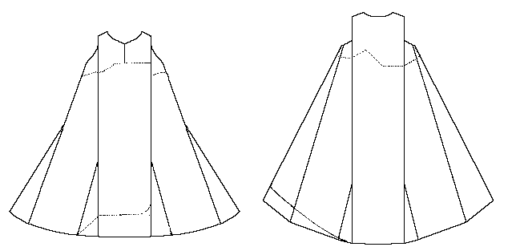
Pattern drawing based on information in Andersson and Franzén.
More usually referred to as the Mantle of St. Birgitta (or, Il Mantello di Santa Brigida), studies by the late Anne Marie Franzen suggest that the garment fragments may possibly be a 14th century woman's surcote. The material is a fine dark-blue/mauve wool, and was likely quite expensive when it was first made.
At the time Franzen studied the garment, it was held by the the Convent of Santa Lucia a Selci in Rome. I am told that it may be found now at Santa Brigida a Campo de'Fiori, also in Rome.
Note that this should not be confused with the "Mantle of St. Brigit".

Some Sources:
- Andersson, Aron and Anne Marie Franzén. Birgittareliker inlånade till Historiska museets utställning "Birgitta och det Heliga landet" 30 november 1973-17 februari 1974. (Antikvariskt arkiv 59) Stockholm: Almqvist & Wiksell, 1975
- Strong, Susannah. Pers Com. (19 Apr 2002) [regarding the location of the item]

Return to Contents
Some Clothing of the Middle Ages - Tunics - St. Birgitta's Cloak or Dress, by I. Marc Carlson, Copyright 1998, 1999.2002 This code is given for the free exchange of information, provided the Author's Name is included in all future revisions, and no money change hands-

