Kyrtles/Cotes/Gowns

Skjoldehamn
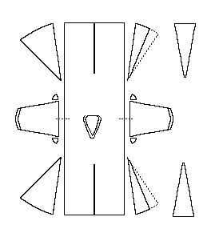Pattern drawing based on Gjessing.

A "bog-find" that has been Radio Carbon dated to about 1000-1210 CE, although it is stylistically similar to clothes from the 13th-14th centuries. It has gores set in the front and on the sides. It is made of a 4-shafted twill.
- Garment Length (over the shoulders): 106-108 cm (41.7-42.5")
- Hem Circumference: 278 cm (109")
- Waist Circumference: c95 cm (37.4")

