

Pouches and Purses
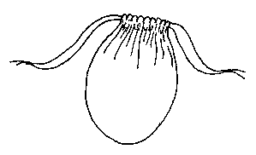
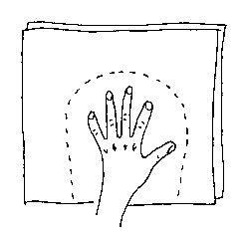
If you're going to one of those events where you need to keep your wallet and car keys on you, you'll find a pouch is a handy substitute for the pockets your costume doesn't have. If you're feeling creative, make several to match your various outfits, or in different sizes for holding change, sweets, and other valuables.

A Simple Pouch:
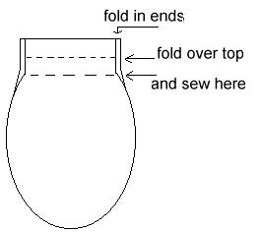
On two layers of fabric trace an oval shape that is larger than your hand. Make one end flat, this will be the top opening. It should be 8-10 inches deep and 6-8 inches across. If it is going to hold your wallet it has to be large enough to get your hand inside.
On the end of the fabric that is going to be the opening fold over the sides a half an inch to the wrong side of the fabric and hem about two inches along each side. Then fold the top over to the wrong side of the fabric one inch and sew it down so there is a channel to thread ribbon through later.
Pin the two pieces right sides together so the top edges meet. Sew around the sides of the pouch being careful to leave the channel at the top open for threading ribbon through.
Turn right sides out.
For the drawstring handles you will need two 18 inch lengths of ribbon or cord and a saftey pin. Do not use metallic cording as it is too rough to slide in the channels when you want to open your pouch.
Use the saftey pin to thread the cords for your handles by pinning the end of the cord or ribbon and working the saftey pin through the channels you sewed. Thread each length of cord through one side of the channel and back through the other, so you have two ends of the same cord on each side of the pouch and when you pull them it closes.
Knot the ends of the cords and trim them if necessary.
When you wear your pouch, tie it securely to your belt. I've seen more people loose their valuables by not securing their pouches...

A Lined Pouch:
You can make a fancy lined pouch by cutting two additional pieces of fabric the same size as your shell pattern. (The outside pieces are called the "shell". The inside pieces are called the "lining".) Satin fabrics make nice linings, but be careful because they can also fray a lot while you are trying to work with them.
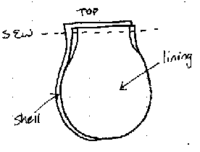
NOTE: If you want to decorate your pouch with embroidery or trim it is better to do it before you start to assemble it. If you want to put your name on your pouch, write it on the right side of one of your lining pieces with a marker that won't wash out.
Fold over and hem the top sides of each of the four pieces as instructed above.
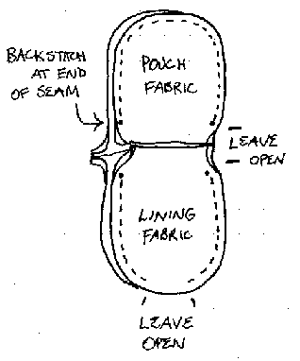
Place the right sides together and sew each shell piece to a lining piece across the top part of the pouch that will become the opening.
Open each half of the pouch, and lay them, right sides together, matching the lining halves and the shell halves. Make sure the top seams are straight and even, or your pouch will be crooked. It's okay if the lining and shell edges don't meet up perfectly, they will be hidden inside the seams.
Sew the shell half, starting at a point just a little above your side hem, all the way around to the other side hem. If you are using a sewing machine, backstitch a little bit to reinforce the seam when you start and finish. If you sew by hand, take a few extra stitches as reinforcement.
Sew the lining half, starting at the side hem with a few reinforcing stitches, and ending near the bottom of the pouch. Leave a space of a couple of inches open so you can turn the whole thing right side out when your seams are done. Sew up both sides of the lining.
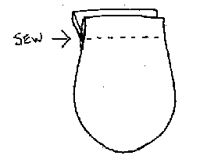
Turn the pouch right sides out. Sew up the hole in the bottom of the lining and stuff it inside the shell where it belongs. Flatten everything out, and smooth the lining down inside the shell.
At the top of the pouch, where you first sewed the lining and shell seams, sew them together again, this time about 1 inch below the top edge of the opening, or as close to the side seams as you can get. This will leave you with a channel on either side of the opening. Thread your cord through as instructed above.

All text and artwork copyright 1990 - 2001 D. Duperault. NOTHING on this site may be reproduced or distributed by any means without my written permission. This information offered in good faith, and worth only what you paid for it.
Send me e-mail
Home
Help Keep this Site Online

